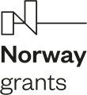 | NORWEGIAN FINANCIAL MECHANISM 2014-2021 | 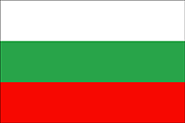

LIST OF CONTRACTS

№ | Project proposals | Project promoter | Project partner | Value/Amount | Duration
1. | “On Focus – improving the national asylum and migration capacities” | Bulgarian Red Cross Association | 1.State Agency for Refugees within the Council of Ministers  2.Euroclub Woman Аssociation | 1 279 150 BGN/  654 029,04 EUR | 16 months, but not later than 30th of April 2024
2. | “BRACE&PROTECT [Capacity-building and policy recommendations for vulnerable third-country nationals, seeking international protection or granted temporary protection]” | European Institute Foundation | NA | 404 404 BGN/  206 771.65 EUR | 15 months
3. | “A helping hand for the refugees from Ukraine” | Caritas Sofia Association | NA | 495 179,08 BGN/  253 184,93 EUR | 12 months
4. | “Improvement of accommodation conditions and provision of social activities for persons accommodated in the centers of SAR with CM” | State agency for refugees within the Council of Ministers | NA | 552 377.20 BGN/  282 430.31 EUR | 16 months, but not later than 30th of April 2024
5. | “Providing comprehensive services and increasing national capacity in the field of asylum and migration” | Foundation “Za dobroto” | Norwegian NGO – Rodna Rech and District “Lozents”, Sofia Municipality. | 391 293.89 BGN  200 068.45 EURO | 16 months, but not later than 30th of April 2024

